Tasty Bites Sales Analysis

1.Business Scenario.
Tasty Bites is a food delivery app operating in multiple cities. The company has noticed that some products generate low profit despite high sales, while others contribute significantly to the bottom line. Management wants to optimize product pricing and promotions to maximize profitability without losing customers.

2. Project Objective
The Analysis focuses on the following objectives:
- Identify high-profit and low-profit products.
- Understand the impact of discounts and promotions on profit margins.
- Recommend pricing strategies to increase overall profitability.

3. Dataset Description
- Source of data – Kaggle.com
- Time period – 2024 – 2025
- Rows – 1000
- Columns – (order_id, order_date, productI_id, product_name, category, quantity, unit_price, cost_per_unit, discount, customer_type, payment_mode)

4.Tools Used
- Microsoft Excel – Initial data exploration and validation.
- PostgreSQL – Used for querying, cleaning, joining, and aggregating data, and for calculating key KPIs to prepare analysis-ready datasets.
- Power BI - Data modelling, DAX measures, and interactive dashboard creation.

5. Data Cleaning & Preparation
- Data Import & Cleaning: Loaded the CSV file into Power Query, removed duplicates, fixed data types, handled missing values and derived calculated columns such as Total Revenue, Total Cost and Name of Days.
- Measure Creation: Created key DAX measures like Average Order Value, Average Total Orders, Gross Profit, Net Profit, Gross Revenue, Net Revenue, Quantity Sold, Total Cost, Total Discount, Total Orders.

6. Key Insights.
1. Which top products generated the highest revenue?
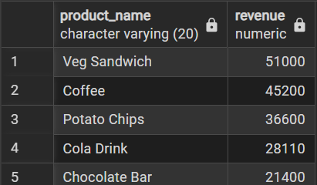
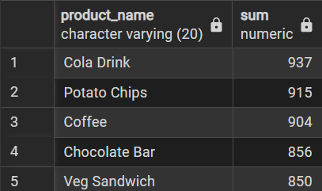
2. Total quantity sold per product.

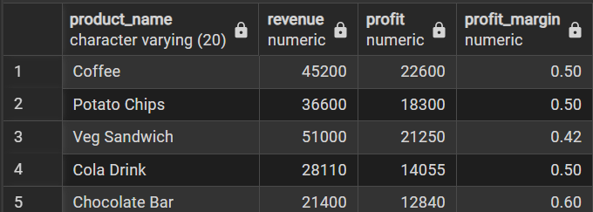
3.Profit Margin per Product?

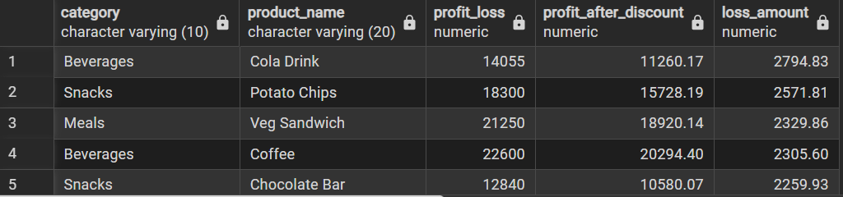
4. Discount Impact: Profit loss due to discounts.


5. Average order value (AOV)?

6. Contribution to Total Profit: Percentage contribution of each product to overall profit?

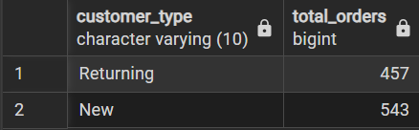
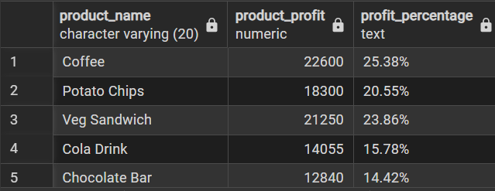
7. Customers by total orders?

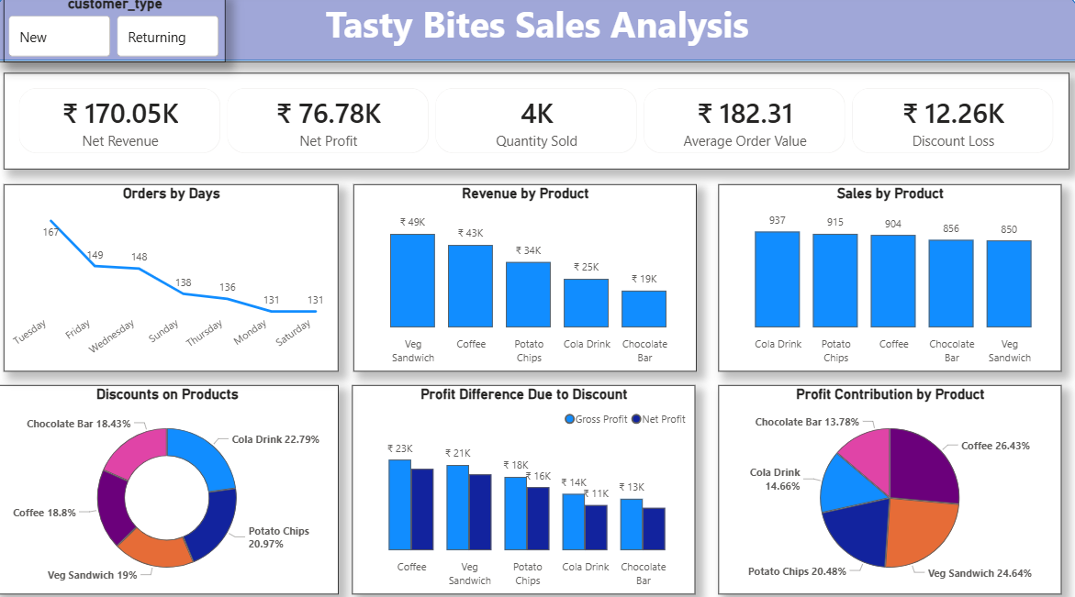

7. Recommendations
- Focus on High-Profit Products
Coffee and Veg Sandwich together contribute over 50% of total profit. These products should be prioritized through better visibility on menus, combo offers, and consistent stock availability to protect and grow profit margins.
- Optimize Discount Strategy
Cola Drink and Potato Chips receive the highest share of discounts, yet their profit contribution is relatively lower. Review discount levels on these items and shift from flat discounts to bundled or conditional offers to reduce unnecessary profit leakage.
- Improve Weekend Performance
Orders show a clear decline on Saturday and Sunday compared to weekdays. Introduce weekend-only deals, family combos, or limited-time offers to boost footfall and order volume during weekends.
- Increase Average Order Value (AOV)
With an AOV of ₹182, upselling opportunities exist. Promote add-ons (drinks, sides, desserts) and value combos at checkout to encourage customers to increase basket size.
- Reduce Discount Loss Impact
Discount loss stands at ₹12.26K, which is significant relative to net profit. Implement targeted discounts for new customers only, while offering loyalty-based rewards for returning customers instead of price cuts.
- Data-Driven Product Promotions
Chocolate Bar shows lower sales and profit contribution. Test cross-selling it with coffee or meal combos rather than standalone discounts to improve its performance without eroding margins.

8. Conclusion.
By optimizing discounts, strengthening high-margin products, and improving weekend sales performance, Tasty Bites can increase profitability without relying heavily on price reductions. A balanced strategy focused on value-based selling and targeted promotions will support sustainable growth.

